

Olympus DPG
Product Requirement Document for Public Grievances Redressal (PGR) & Trade License
Private and confidential
NOVEMBER 2025

Contents
1 Public Grievances & Redressal (PGR) 4
1.1 About Public Grievances & Redressal (PGR) 4
1.2 Public Grievance Module (PGR) Functional Specifications 5
1.2.1 Introduction 5
1.2.2 Functional Scope 5
1.2.3 Registration, Login & Creation of User Profile 5
1.2.4 Lodging Grievance 5
1.2.5 Assigning Grievance 6
1.2.6 Resolving Grievance 6
1.2.7 Managing Grievance 6
1.2.8 Tracking Complaint 7
1.2.9 Dashboards & Reports 7
1.2.10 General Features 7
1.3 Grievance Types List 8
1.4 PGR Workflows 9
1.4.1 Workflow Overview 9
1.4.2 PGR Workflow Requirement 9
1.4.3 Intended Audience & Objectives 9
1.4.4 Workflow Specifics 9
1.4.5 Impacts 11
1.4.6 Other Features and Functionalities in PGR 11
1.5 Architecture 11
1.5.1 Architecture Overview 11
1.5.2 Solution Architecture 12
1.5.3 Workbench UI 13
1.5.4 Employee Service & UI (HRMS) 13
1.5.5 Inbox Service (v2) 13
1.5.6 Low-Level Design (LLD) 13
1.5.7 API Contracts 14
1.5.8 Data Model 14
1.5.9 Process Flow 16
1.5.10 Error Handling 17
1.5.11 Integrations 17
1.5.12 Security Design 17
1.5.13 Performance Considerations 17
1.5.14 Sequence Diagram 17
1.5.15 Deployment Components 18
1.5.16 Data Flow Diagram (DFD) – Grievance 18
1.5.17 Public Grievance Redressal API 21
1.5.18 Public Grievance Redressal ER Diagram 24
2 Trade License (TL) Issuance and Payment 26
2.1 About TL 26
2.2 TL Issuance and Payment Module Functional Specifications 26
2.2.1 Introduction 26
2.2.2 Functional Scope 27
2.2.3 Registration, Login and Creation of User Profile 27
2.2.4 Applying for a Trade License 27
2.2.5 Trade License Issue 28
2.2.6 Modifications to a Trade License 28
2.2.7 Renewal of a Trade License 28
2.2.8 Payment and Fee 28
2.2.9 Dashboards and Reports 28
2.2.10 General Features 29
2.2.11 List of Features- Trade License 29
2.1 Architecture 30
2.1.1 Architecture Overview 30
2.1.2 Solution Architecture 31
2.1.3 Workbench UI 32
2.1.4 Employee Service & UI (HRMS) 32
2.1.5 Inbox Service (v2) 32
2.1.6 Low Level Design (LLD) 32
2.1.7 API Contracts (key endpoints) 33
2.1.8 Data Model (Tables, fields, indexes) 34
2.1.9 Fee Calculation & Demand Generation 36
2.1.10 Workflow Design 36
2.1.11 Sequence Flows (high-level) 36
2.1.12 Integrations 36
2.1.13 UI/UX Details 37
2.1.14 Security & RBAC 37
2.1.15 Non-Functional Requirements & Perf 37
2.1.16 Error Handling & Codes (examples) 37
2.1.17 Monitoring & Logging 37
2.1.18 Sample DB DDL (Postgres snippets) 38
2.1.19 Test Cases (high-level) 38
2.1.20 Sample JSONs 38
2.1.21 Data Flow Diagram (DFD) Level 0 – Context Diagram (DIGIT Trade License Module) 39
2.1.22 DFD Level 1 – Major Functional Breakdown 40
2.1.23 DFD Level 2 – Detailed Breakdown of Key Modules 40
2.1.24 API specification for Trade License 43
2.1.25 Trade License – ER Diagram (Textual Representation) 46
2.1.26 Explanation of DIGIT TL Core Entities 48
3. CI/CD Lifecycle for PGR and TL 50
3.1. Overview 50
3.2. CI vs CD Pipeline Breakdown 51
3.3 Environment Deployment Architecture 52
3.4 Infrastructure Architecture for DIGIT TL & PGR on AWS EKS 53

Product Requirements Document for Public Grievance & Redressal and Trade License

About Public Grievances & Redressal (PGR)
The DIGIT Public Grievance & Redressal (PGR) system is a web and mobile platform used to register and address public grievances. It allows citizens to submit complaints anytime and from any location. Complaints are sent to the relevant municipal departments and staff, who work on resolving them within the defined timelines. This digitized and configurable platform helps in faster and more efficient handling of civic issues, giving urban local bodies a clear system to categorize complaints and take timely corrective actions.
Key Features
- Efficient public grievance redressal process
- Simple user registration and login
- Easy complaint and sub-complaint selection
- GIS-based location tagging
- Convenient complaint status tracking
- Interactive dashboards
- Auto-escalations and SLA management

About Trade License(TL) Issuance and Payments
DIGIT – Trade License (TL) Issuance and Payment helps local government bodies regulate trading establishments. It also safeguards the public from potential health risks or inconveniences caused by business operations. Using DIGIT–TL, traders can obtain trade certificates in a simplified way while ensuring compliance with government rules and safety standards. The module provides both citizens and officials a convenient and transparent system for processing trade licenses.
Key Features:
DIGIT Trade License Issuance and Payment module enables citizens to:
- Apply for a new Trade License or renew an existing one
- Upload all required documents for the license
- Make online payments for new or renewal fees through the payment gateway
- Receive email and SMS notifications for application updates and pending renewals
- Download the Trade License, payment receipts, and acknowledgement receipts online
DIGIT Trade License Issuance and Payment module enables employees to:
- Create flexible, role-based workflows
- Configure fee calculation logic for licenses
- View custom dashboards for module-specific statistics
- Filter and search applications using advanced configurable search options

Public Grievances & Redressal (PGR)

Public Grievance Module Functional Requirement Specifications

Introduction
The PGR module allows citizens to submit complaints and monitor their progress. Employees use the system to track and resolve these grievances quickly. The platform is accessible on both web and mobile through a responsive interface.

Functional Scope
The PGR module supports the following key features:
- Registration, Login and Creation of User Profile
- Lodging a Grievance
- Assigning a Grievance
- Resolving a Grievance
- Manage Grievances
- Track Grievances
- Dashboards and Reports
- General Features

Registration, Login & Creation of User Profile
This component provides the following capabilities:
- OTP-based login for citizens on Web/Mobile
- OTP-based login for employees on Web/Mobile
- Language selection during first-time registration for both citizens and employees
- Ability for citizens and employees to create a personalized profile on the Web App
- Login credentials for different employee hierarchies
- Role-based access to perform grievance-related actions

Lodging Grievance
A citizen or a Citizen Service Representative (CSR) can file grievances in the PGR system. Users can upload relevant photos along with the complaint. To specify the complaint location, the user can enter details such as city, mohalla, house number, and other information, or select the location on a map. Once the complaint is submitted, a unique complaint number is generated.
Key capabilities of this component:
- Citizens can lodge and track grievances through the Web App
- Employees can assign, reassign, and resolve grievances through the Web App
- Citizens can upload photographs
- Citizens can select a grievance from a predefined list
- Citizens can enter the complaint address
- Citizens can add additional details about the grievance
- CSC employees can file a grievance on behalf of a citizen
- CSC employees can capture location, grievance medium, grievance type, and other details
- The system maintains a two-level grievance list
- Grievances are mapped to the relevant departments
- The system generates a unique ticket number for each complaint based on the complaint type and shares it with the citizen through SMS, WhatsApp, and/or email

Assigning Grievance
The assigning officer has access to a dashboard that displays all unassigned grievances. They can open any grievance to view its details and expected resolution timeline. Based on the information, the assigning officer can assign the grievance to the appropriate employee from a department-wise list. If needed, the grievance can also be re-assigned, either due to incorrect assignment or any other valid reason.
Key capabilities of this component:
- Assigning Officer can assign grievances to employees
- Assigning Officer can reject grievances with a reason
- Assigning Officer can reassign grievances

Resolving Grievance
Employees can view all grievances assigned to them through their dashboard and mark them for closure. Each grievance shows its details and expected resolution timeline. After resolving an issue, the employee can upload photos as proof and add comments. Using the Share feature, grievance details can be sent to contractors via WhatsApp, SMS, email, and other channels. If the citizen is not satisfied with the resolution, the grievance can be reopened. Citizens can also give feedback and rate the resolution.
Key capabilities of this component:
- Last Mile Employee can upload photographs and comments after resolving a grievance
- Last Mile Employee can request a reassignment of a grievance
- Last Mile Employee can contact the Assigning Officer over a call

Managing Grievance
Employees can access a dashboard showing all open grievances and select any grievance to view its details and expected closure timeline. They can also request a reassignment by choosing a reason from the list, after which the request goes to the assigning officer, who may reassign it to another employee. The system provides different interfaces for Assigning Officers, Employees, and CSRs.
The Assigning Officer can see tabs for unassigned and assigned grievances submitted by citizens, as well as open and closed grievances, and can access PGR reports. Employees can view open and closed grievances assigned to them. CSRs can view and search all grievances filed on behalf of citizens. The system also supports searching, sorting, and refreshing grievance lists.
Key capabilities of this component:
- Assigning Officer can view the Grievance Worklist (Inbox)
- Assigning Officer can view all grievances
- Assigning Officer sees auto-prioritized lists based on SLA
- Assigning Officer can review submitted grievances
- Last Mile Employee can view all grievances assigned to them
- Last Mile Employee sees auto-prioritized lists based on SLA
- Last Mile Employee can review submitted grievances
- CSCs can search and view grievances using grievance number, phone number, or complainant name
- Citizens can reopen a grievance if they are not satisfied with the resolution
- Citizens can rate the grievance after resolution

Tracking Complaint
Key capabilities of this component:
- Citizens can view all grievances they have filed, both pending and completed
- Citizens receive notifications through the App, SMS, or email for every grievance update
- Citizens can view the complete grievance timeline in the app
- Citizens can interact with the municipality through calls and comments
- Assigning Officers can track assigned complaints with a timeline view
- Assigning Officers receive updates on grievance progress
- Assigning Officers can interact with the Last Mile Employee through calls

Dashboards & Reports
PGR reports give an overall operational view of the grievance system across the city. They help city managers—commissioners, department heads, and administrators—monitor the number of complaints received and track how well the ULB and its employees are resolving them. Reports can be filtered by date and downloaded in PDF or XLS formats.
Key capabilities:
- Grievance key statistics: Dashboards and reports showing grievances filed, pending, completed, and overdue, with ULB-wise and location-wise details
- SLA performance: Dashboards and reports showing SLA performance and time taken for grievance resolution
- State Dashboard: Drill-down views across various administrative levels
- Reports: View reports by State, ULB, grievance types, and departments

General Features
Auto Routing – The system can automatically route complaints to the assigning officer (at the city or department level), who then assigns them to the last mile employee.
Auto Escalation – Complaints that are not resolved within the defined timelines are automatically escalated to the ULB or the concerned department head.
Notifications – The system can send notifications to citizens at different stages such as complaint submission, status updates, and resolution. Notifications can be sent in the language chosen by the ULB and delivered through SMS, WhatsApp, and email.
Configurable Masters – The system includes master data components that can be configured based on State requirements:
- Assigning Officer: View, edit, and update profile
- Assigning Officer: Department-wise employee list
- Last Mile Employee: Employee directory
- Configuration of assigning officer: Can be set at ULB or department level

Grievance Types List
The list of grievance types and mapped sub types and mapped sub types
Grievance Types | Grievance Sub-Types
Streetlights | - Streetlight not working  - Installation of new streetlight
Water & Sewerage | - Illegal discharge of sewage  - Block/overflowing sewage  - Shortage of water  - Dirty water supply  - Broken water pipe/leakage  - Water pressure is very less  - No water supply  - Sewage main hole cover missing or broken  - Sewerage main hole cover raising  - Cleaning of sewerage moves slurry gear
Property Tax/ House Tax | - How to pay property tax  - Wrong calculation  - Receipt not generated  - Others
Roads & Footpaths | - Damaged road  - Waterlogged road  - Manhole cover missing or broken  - Damaged/Blocked footpath  - Construction material lying on road  - Illegal rehries on road  - Road jalli broken
Mosquitoes | - Request spraying or fogging operation
Animals | - Stray animals  - Dead animals
Public Toilets | - Dirty or smelly public toilets  - Public toilet damaged  - No water or electricity in public toile
Land Violations | - Illegal shops on footpath  - Illegal construction  - Illegal parking
Trees | - Illegal cutting of trees  - Cutting or trimming of tree required
Open Defecation | - Open defecation
Parks | - Parks require maintenance
Others | - Specify

PGR Workflows

Workflow Overview
Workflows are a series of steps that move a process from one state to another, driven by different types of actors—humans, systems, or time-based events—to achieve a specific goal, such as onboarding an employee, approving an application, or granting access to a resource.

PGR Workflow Requirement
Workflow services add flexibility and allow the PGR system to adapt as new features are introduced. In PGR, workflows support evolving needs such as escalation, routing, and other future enhancements.

Intended Audience & Objectives
This document is for the Tech team to understand the workflow requirements within PGR and determine whether the existing DIGIT workflow service can meet these requirements.

Workflow Specifics
- Role-Action Mapping:
  - Citizen: Submit a complaint, Reopen complaint, Rate (not part of workflow)
  - CSR: Submit a complaint, Reopen complaint
  - GRO: Reject complaint, Assign complaint
  - LME: Request reassignment, Resolve complaint
- Actions and Their Meaning
SN | Action | Description
1 | Submit | This action will raise the complaint
2 | Re-open complaint | Once a complaint is resolved or rejected, this action will re-submit the complaint, and it will go through the workflow
3 | Reject Complaint | This action will reject the complaint and then gives the option to citizen/CSR to RE-OPEN within 5 days
4 | Assign complaint | This action will help GRO/DGRO to assign the complaint to last mile employee (LME) by giving them LME list to choose from
5 | Request for Re-assign | This action will send back complaint to GRO/DGRO for reassignment
6 | Resolve complaint | This action resolves the complaint then gives the option to citizen/CSR to RE-OPEN within 5 days*
7 | Re-assign complaint | This action will help GRO to re-assign complaint if assignment made by him is not accurate or any other reason
*5 days is the default number of days to reopen the complaint. This time frame is configurable.

1. Workflow:
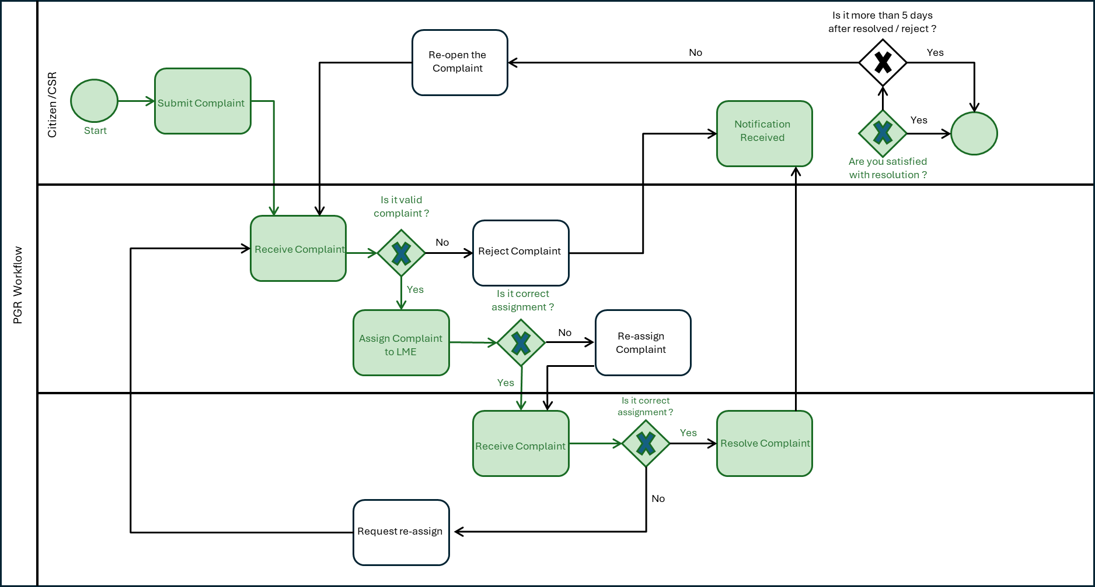
*Green color indicates the ideal workflow path.

2. Configuration:
SN | Current State | Action | Next State | Actors
1 | Initiated | Submit Complaint | Pending at GRO | Citizen/CSR
2 | Rejected | Re-open | Pending at GRO | Citizen/CSR
3 | Resolved | Re-open | Pending at GRO | Citizen/CSR
4 | Pending at GRO | Assign complaint | Pending at LME | GRO/DGRO
5 | Pending at GRO | Reject | Rejected | GRO/DGRO
6 | Pending at LME | Re-assign | Pending at LME | GRO/DGRO
7 | Pending at LME | Request Re-assign | Pending at GRO | LME
8 | Pending at LME | Resolve complaint | Resolved | LME
9 | Pending at LME | Reject | Rejected | LME

Impacts

- Employee Inbox UI on Web
- SLA configuration at the ULB

Other Features and Functionalities in PGR
All other features and functionalities should remain unaffected like complaint types, uploading a photo, capturing address, UI for the citizen, search complaint, complaint history, comments etc.

High Level Design (HLD) for Public Grievance and Redressal (PGR)
This section provides a high-level overview of the design architecture behind the DIGIT Public Grievance & Redressal (PGR) module. It explains how different services interact to handle grievance registration, routing, resolution, and monitoring.

Architecture Overview
Below is the high-level architecture diagram for the Public Grievance & Redressal (PGR) module:
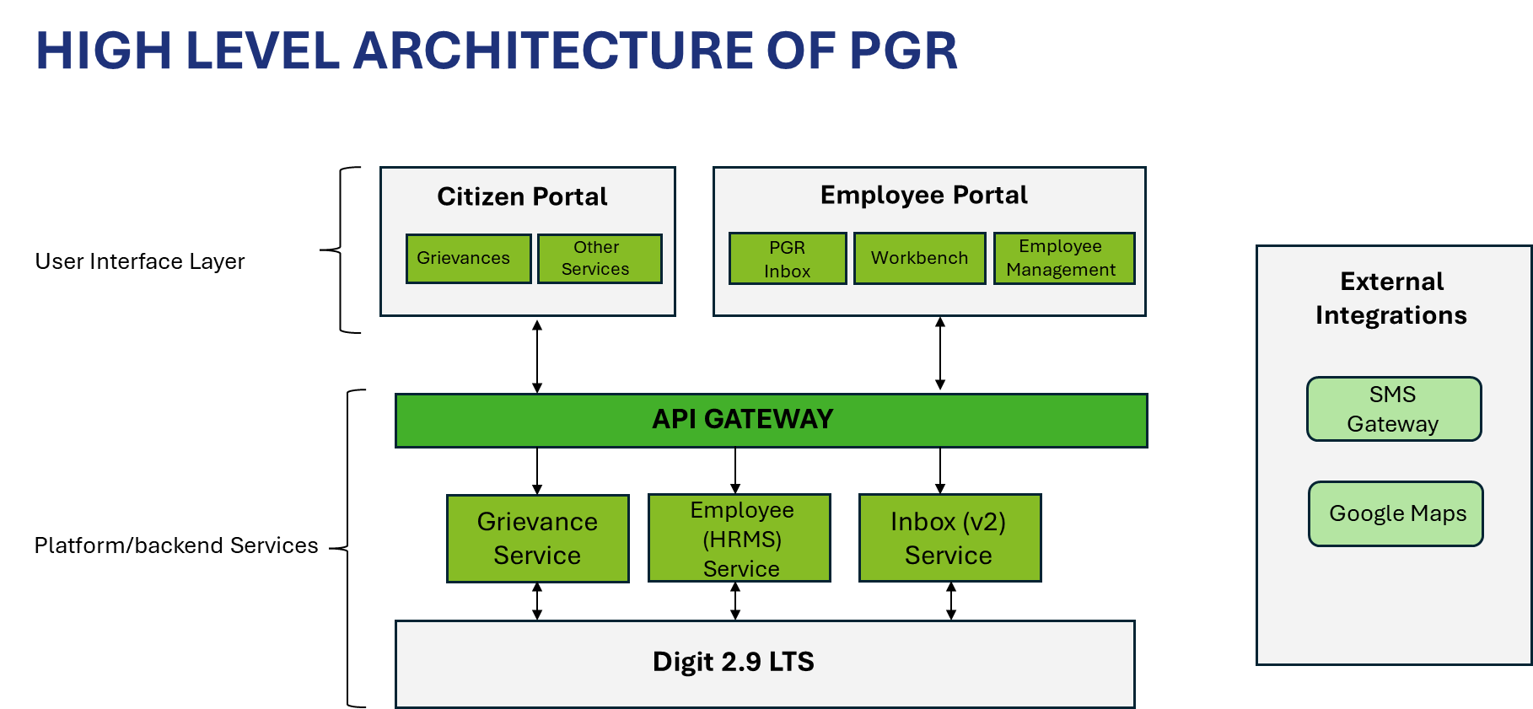
The diagram below provides a detailed view of the system components:
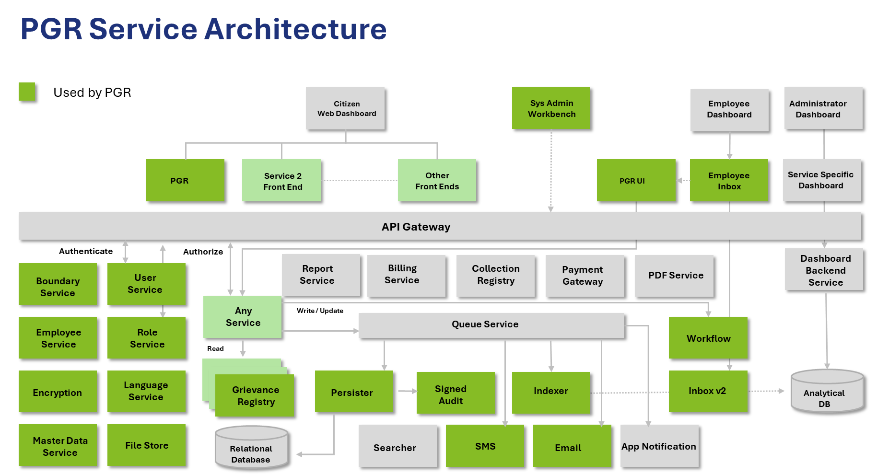

Solution Architecture
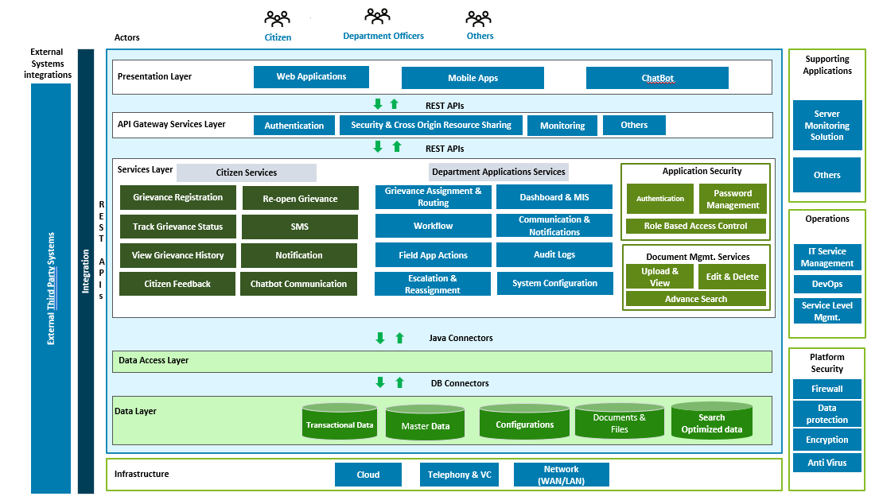

Workbench UI
The Workbench provides a UI to create, search, and edit master data for all services on the DIGIT platform. It functions with MDMS v2.

Employee Service & UI (HRMS)
This service is used to create, edit, search, and map employees to roles. Roles are defined as master data. The GRO, CSR, and LME roles in CCRS are assigned to employees through this service. For more details, refer to the Employee Service documentation.

Inbox Service (v2)
The Public Grievance & Redressal module uses the Inbox Service to show employees the action items that need their attention. Inbox v2 uses ElasticSearch indexes, which are updated by the Grievances service. The query logic is configured and stored as master data.

Low-Level Design (LLD) for Public Grievance and Redressal (PGR)
The Public Grievance Redressal (PGR) module in DIGIT enables citizens to submit grievances, track status, interact with departments, and receive closure updates. The system integrates with workflow, MDMS, location, user service, and notification services.

PGR Service Flow
Component | Description
PGR Service | Manages complaint creation, updates, search, and status.
Workflow Service | Manages complaint lifecycle (Open → Assigned → Resolved → Closed).
User Service | Provides citizen and employee details.
Location Service | Ward, locality, boundary mapping.
MDMS | Masters: categories, subcategories, SLA, priority, channels.
Notification Service | SMS, Email, In-App notifications.
Filestore Service | Attachment uploads.

Module Function Breakdown

Citizen Operations
- File complaint (mobile/web)
- Add geo-location
- Upload images
- Track status
- Rate feedback

Internal Operations
- Auto-assign complaint
- Department routing
- SLA tracking
- Escalation workflow
- Commenting, reassigning
- Closure with proof

API Contracts

Create Grievance
POST /pgr/v2/request/_create
Request Body (Key fields):
{
"RequestInfo": {},
"service": {
"tenantId": "pb.amritsar",
"serviceCode": "Garbage",
"description": "Garbage not collected",
"lat": 31.63,
"long": 74.87,
"address": "Ward 12",
"source": "mobileapp",
"attributes": {
"subCategory": "Doorstep collection",
"priority": "HIGH"
}
}
}

Update Request
POST /pgr/v2/request/_update

Search
POST /pgr/v2/request/_search

Data Model
The data model for the Public Grievance & Redressal module defines how grievance information is stored, tracked, and processed. It outlines the relationships between the different entities—citizen, grievance, service, status, actions, and others—required to support the complete grievance lifecycle.

Table: service_request
Field | Type | Description
uuid | UUID | Unique request ID
tenantId | VARCHAR | ULb/State code
serviceCode | VARCHAR | Category of complaint
source | VARCHAR | web/mobile/email/call center
status | VARCHAR | Open, Assigned, In-progress, Resolved, Rejected, Closed
accountId | VARCHAR | Citizen UUID
description | TEXT | Complaint description
createdBy | VARCHAR | User UUID
createdTime | BIGINT | Timestamp
lastModifiedBy | VARCHAR | User UUID
lastModifiedTime | BIGINT | Timestamp
rating | INT | Feedback rating
feedback | TEXT | Citizen comments
sla | BIGINT | SLA for complaint

Table: address
Field | Type | Description
uuid | UUID | Primary key
houseNo | VARCHAR | House number
buildingName | VARCHAR | Optional
street | VARCHAR | Street name
locality | VARCHAR | Maps to Location service
city | VARCHAR
tenantId | VARCHAR
pincode | INT
lat | DOUBLE
lng | DOUBLE
serviceRequestId | UUID | FK → service_request.uuid

Table: audit_details
Field | Type
createdBy | VARCHAR
createdTime | BIGINT
lastModifiedBy | VARCHAR
lastModifiedTime | BIGINT

Table: service_attributes
Field | Type | Description
uuid | UUID | Primary key
serviceRequestId | UUID | FK
key | VARCHAR | e.g., "subCategory"
value | VARCHAR | e.g., "Drain Blockage"

Table: service_documents
Field | Type | Description
uuid | UUID | Primary key
serviceRequestId | UUID | FK
fileStoreId | VARCHAR | Link to filestore
documentType | VARCHAR | E.g., attachment, closing-proof

Workflow-related Tables
Field | Type
businessId | VARCHAR
action | VARCHAR
moduleName | VARCHAR
tenantId | VARCHAR
state | VARCHAR
comments | TEXT
assignee | VARCHAR

Process Flow
Following are different process flows of Public Grievance System.

Complaint Creation Flow
- Citizen submits complaint
- Validation → master data (category, subcategory)
- Address and location mapping
- Insert into service_request
- Trigger workflow → initial state = OPEN
- Auto-assign based on:
  - Department
  - Locality
  - Service code
- Notification sent

Complaint Assignment
- Workflow transition action ASSIGN
- Update assignee
- Change status → ASSIGNED
- Notify assignee (SMS / Inbox)

Complaint Resolution
- Action → RESOLVE
- Attach closure document
- Add employee comments
- Update status, SLA consumption
- Citizen notified

Complaint Closure
- Citizen gives feedback (optional)
- Auto close or admin close
- SLA report generated

Error Handling
Scenario | Error Code | Message
Invalid serviceCode | 400 | "Service Code not found in MDMS"
Missing location | 400 | "Locality not found"
Workflow transition issue | 409 | "Invalid action for current state"
File upload issue | 500 | "File store service error"

Integrations

With Workflow
- Module name: PGR
- States: OPEN → ASSIGNED → INPROGRESS → RESOLVED → CLOSED

With MDMS
- service categories
- escalation rules
- department mapping

With Notification Service
- SMS templates:
  - Complaint Registered
  - Assigned to officer
  - Resolved update
  - Closed

Security Design
- API authentication: JWT token
- User validation using User Service
- Role-based access
- Tenant boundary enforcement

Performance Considerations
- Indexing on:
  - serviceCode
  - status
  - tenantId
  - createdTime
- Cache MDMS with TTL
- Pagination for searches

Sequence Diagram
Complaint Registration
Citizen → PGR API → Validate → Database Insert → Workflow Start → Notification → Response
Officer Resolution
Officer → PGR Update API → Workflow transition → DB update → Notification → Close

Deployment Components
- pgr-service
- pgr-notification-consumer
- workflow-v2 service
- egov-user service
- egov-location
- filestore
- mdms

Data Flow Diagram (DFD) – Grievance
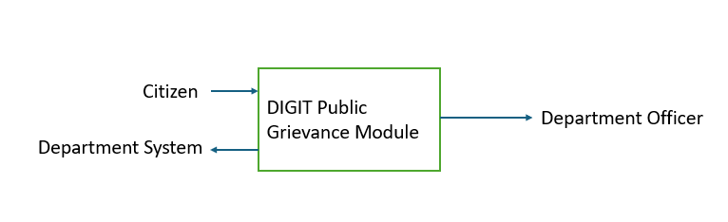
Explanation:
- Citizen submits grievances.
- DIGIT PG Module processes and forwards to relevant department officers.
- Officers act and update status.
- Citizen receives updates/closure.

DFD Level 1 – Major Functional Breakdown
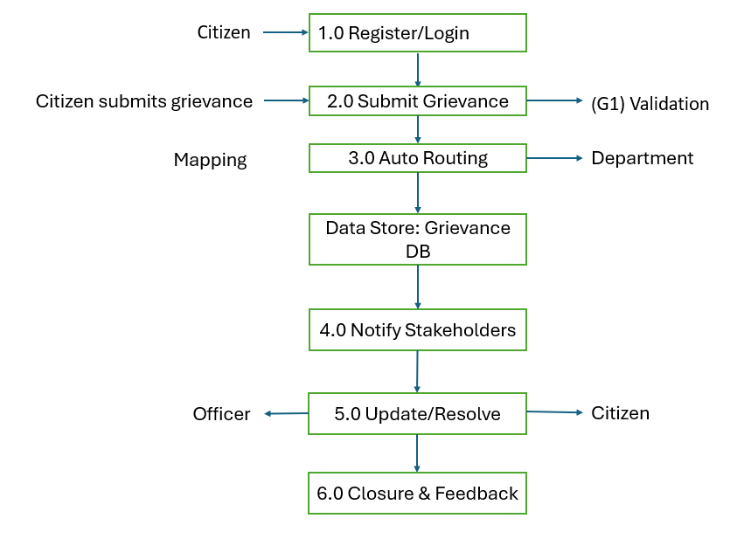

DFD Level 2 – Detailed Breakdown of Key Modules
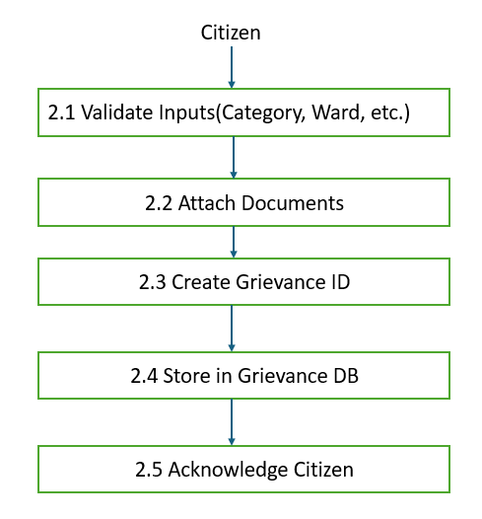

Level 2 for 3.0 Auto Routing
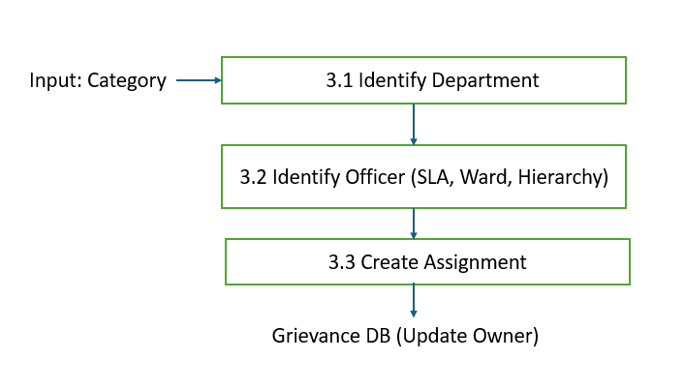

Level 2 for 5.0 Update/Resolve Grievance
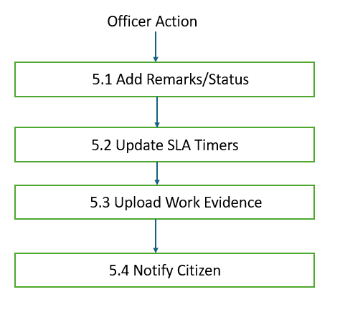

Level 2 for 6.0 Closure & Feedback
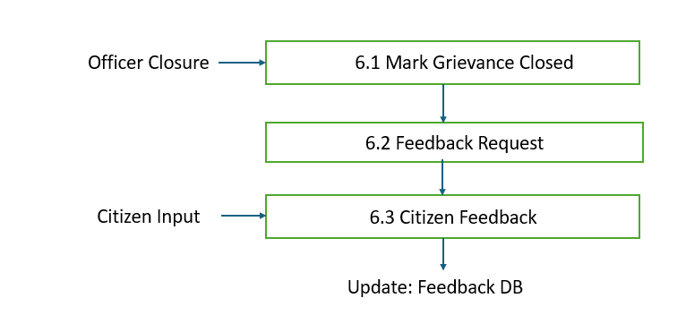

Public Grievance Redressal API
info:
title: DIGIT Public Grievance Redressal API
version: 1.0.0
description: API spec for DIGIT PGR module

servers:
- url: https://{host}
variables:
host:
default: api.digit.org

paths:
/pgr-services/v2/request/_create:
post:
summary: Create a grievance request
tags:
- PGR
requestBody:
required: true
content:
application/json:
schema:
$ref: '#/components/schemas/PGRRequest'
responses:
'201':
description: Created
content:
application/json:
schema:
$ref: '#/components/schemas/PGRResponse'

/pgr-services/v2/request/_update:
post:
summary: Update a grievance request
tags:
- PGR
requestBody:
required: true
content:
application/json:
schema:
$ref: '#/components/schemas/PGRRequest'
responses:
'200':
description: Updated

/pgr-services/v2/request/_search:
post:
summary: Search grievance requests
tags:
- PGR
requestBody:
required: false
content:
application/json:
schema:
$ref: '#/components/schemas/PGRSearchRequest'
responses:
'200':
description: List of complaints
content:
application/json:
schema:
$ref: '#/components/schemas/PGRResponse'

components:
schemas:
RequestInfo:
type: object
properties:
apiId: { type: string }
ver: { type: string }
ts: { type: number }
authToken: { type: string }

Address:
type: object
properties:
doorNo: { type: string }
street: { type: string }
locality: { type: string }
city: { type: string }
lat: { type: number }
lng: { type: number }

PGRService:
type: object
properties:
tenantId: { type: string }
serviceCode: { type: string }
description: { type: string }
source: { type: string }
status: { type: string }
accountId: { type: string }
address:
$ref: '#/components/schemas/Address'
documents:
type: array
items:
type: object

PGRRequest:
type: object
properties:
RequestInfo:
$ref: '#/components/schemas/RequestInfo'
service:
$ref: '#/components/schemas/PGRService'

PGRResponse:
type: object
properties:
ResponseInfo: { type: object }
service:
type: array
items:
$ref: '#/components/schemas/PGRService'

PGRSearchRequest:
type: object
properties:
RequestInfo:
$ref: '#/components/schemas/RequestInfo'
searchCriteria:
type: object
properties:
serviceCode: { type: string }
applicationStatus: { type: string }
mobileNumber: { type: string }
tenantId: { type: string }
ids:
type: array
items: { type: string }

Public Grievance Redressal ER Diagram
This diagram shows the core entities and relationships.
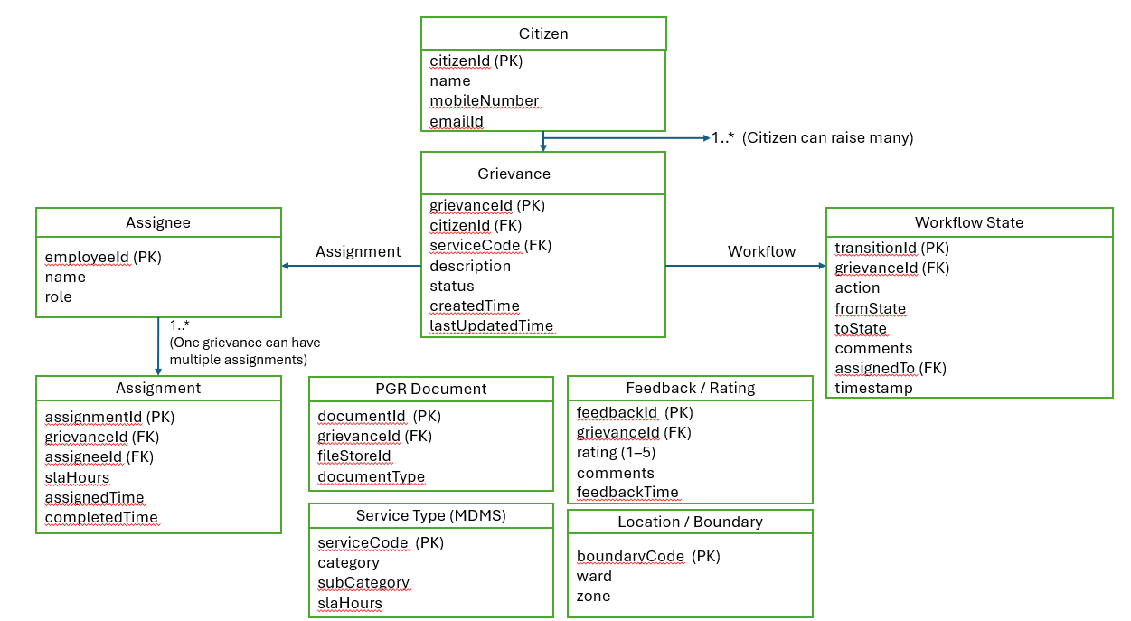

Trade License (TL) Issuance and Payment

TL Issuance and Payment Module Functional Specifications

Introduction
The Trade License Issuance and Payment module provides a digital interface that allows citizens to apply for a Trade License and pay the associated fees online.
The module enables:
- Ease of doing business: Traders can apply for new licenses, renewals, amendments, and supplemental licenses
- Regulatory tracking: Administrators can monitor and manage regulatory processes
- Shorter timelines: Automated and streamlined licensing processes help businesses get operational faster
- Data-driven decision making: The system collects useful information on economic activity and employment within the ULB

Functional Scope
The following list summarizes the key features supported by the Trade License Issuance and Payment module:
- Registration, Login and Creation of User Profile
- Applying for a Trade License
- Trade License Issue
- Modifications to a Trade License
- Renewal of Trade License
- Payments and Fee
- Dashboards and Reports
- General Features

Registration, Login and Creation of User Profile
Key capabilities of this component:
- OTP-based login for citizens through the Web/Mobile App
- OTP-based login for employees through the Web/Mobile App
- Language selection during first-time registration for both employees and citizens
- Ability for citizens and employees to create a personalized profile on the Web App
- Login credentials for different employee hierarchies
- Role-based access to perform actions related to the Trade License module

Applying for a Trade License
A user can apply for a new Trade License (TL) through the system. The user selects the license type, enters trade details, owner details, and uploads the required documents. After reviewing the information, the application can be submitted. Counter employees can also apply for a TL on behalf of citizens. The system includes workflow integration, enabling stage-wise approvals before the Trade License is issued.
Key capabilities of this component:
- Citizens can apply for a new Trade License through the mobile app or web
- Citizens/CSCs can capture trade details, trade units, accessories, owner details, address, purpose, date of issuance, license number, etc.
- Citizens/CSCs can upload documents
- Citizens/CSCs can view fee breakup based on the selected trade
- Citizens/CSCs can select multiple accessories related to the trade
- Citizens/CSCs can apply for multiple Trade Licenses
- Citizens/CSCs can download/print the application summary
- Citizens/CSCs can download/print the trade reference number
- Citizens/CSCs can view applied licenses
- The system supports service delivery online and through CSCs
- The portal displays all required information, including processes and documents needed
- The system assigns a unique identification number based on license type for all future transactions

Trade License Issue
The system assigns the application to the appropriate inspector for survey and verification. After submission, the application first goes to the document verifier. Once documents are verified, the next stage is the field inspection. After the field inspector approves the report, the application moves to the approver for final approval of the Trade License.
Key capabilities of this component:
- Document Verifier verifies and either forwards or rejects the application
- Licensing Inspector verifies and forwards the application
- Licensing Inspector can send back or reject the application
- Licensing Inspector can approve the application
- Citizen pays the license fee online or at the CSC after the verification process
- CSC can collect the fee after verification
- The system supports printing the license and sending it via email
- The system sends SMS alerts for inspection dates, approvals, and rejections
- The inspector can enter field visit details, and the system generates a field visit report that is automatically routed to the superintendent

Modifications to a Trade License
The system allows editing or updating an application based on the inspection report submitted against that application.

Renewal of a Trade License
The system provides a smooth renewal process for both citizens and employees, helping reduce unlicensed trades and improving revenue. SMS and email notifications and reminders are sent based on the renewal cycle.

Payment and Fee
Key capabilities of this component:
- Citizens can pay the license fee after the verification process
- CSCs can collect the fee after verification
- The system notifies the applicant about the payment through SMS or email
- The system generates a receipt for the payment
- Supported payment modes include card (offline), cash, cheque, and DD

Dashboards and Reports
The module provides the following reports:
- Cancelled Receipt Register Report
- TL Collection
- TL Application Status — showing the number of licenses approved or rejected
- TL ULB-wise Status
- State Dashboard — view total licenses, licenses issued, payment collected, and payment distribution

General Features
Notifications - The system can send notifications to citizens at different stages such as verification completion, payment reminders, and payment confirmations. These notifications can be delivered in the ULB-selected language through SMS, WhatsApp, and email.
Configurable Masters - The system provides master data components that can be configured based on State requirements:
- Charges & Calculation: Calculation engine, rebate, penalty
- Rate Master
- State Masters: Trade ontology, document list, accessories, ownership, employee data mapping, boundary data mapping, fee matrix (license fees)

List of Features- Trade License
List of Functionalities | Corresponding Features
Registration, Login, Creation of User Profile | Provision for Language Selection during first-time registration via Mobile/ Web App.
OTP Based Login for Citizen/ Employee via Mobile/ Web App
Login Credentials for the various hierarchy of employees
Provision of Personalized Profile for Citizen/ Employee on Web App
Applying for a Trade License | Citizen/CSCs: Enters Trade Details, Trade Units, Accessories, Owner Details.
Citizen/CSCs: Upload Documents
Citizen/CSCs: ULB Wise Trade Selection
Citizen/CSCs: Calculation Breakup Based on Selected Trade
Citizen/CSCs: Multiple Accessories Field Count
Citizen/CSCs: Multiple Trade License.
Citizen/CSCs: Download/Print Application Summary
Citizen/CSCs: Download/PRINT Trade Reference No
Citizen/CSCs: View the applied licenses.
Citizen: Pays for the license post verification process.
CSCs: Collects Fee post verification.
Trade License Issue | Document Verifier: Verify & Forward/ Reject the application
Licensing Inspector: Verify and Forward/ Send back/ Reject the Application.
Licensing Officer: Approve/ Send back the Application
Licensing Officer: Reject/ Cancel the Application
Modification to a Trade License | Edit/ Update the Application based on the Inspection report against the application.
Renewal of a Trade License | Renew trade license.
Payment and Fee | Configurable Workflow Rights: Edit & Payment Collection
Payments & Collection: Various Payment Modes
Dashboards and reports | Cancelled Receipt Register Report
TL Collection
TL Application Status- showing the number of licenses approved/rejected.
TL ULB Wise Status
State Dashboard: View Reports for Total Licenses, Licenses Issued, Payment Collected, Payment Distribution
General features | Notifications: SMS Notifications
Charges & Calculation: Calculation Engine
Charges & Calculation: Rebate/ Penalty- Date Based
Charges & Calculation: Ad-Hoc Rebate/ Penalty
Charges & Calculation: Exemptions Trade Type & Owner Type
Configuration masters | Configurable Workflow Rights: Edit & Payment Collection
Configurable Verification & Approval

Architecture
This section provides a high-level overview of the design architecture behind the DIGIT – Trade License (TL) Issuance and Payment module. It explains how different services interact to handle Trade license Issuance, renewal, payment, routing, approval, and monitoring.

Architecture Overview
Below is the high-level architecture diagram for the Trade License (TL) Issuance and Payment module:
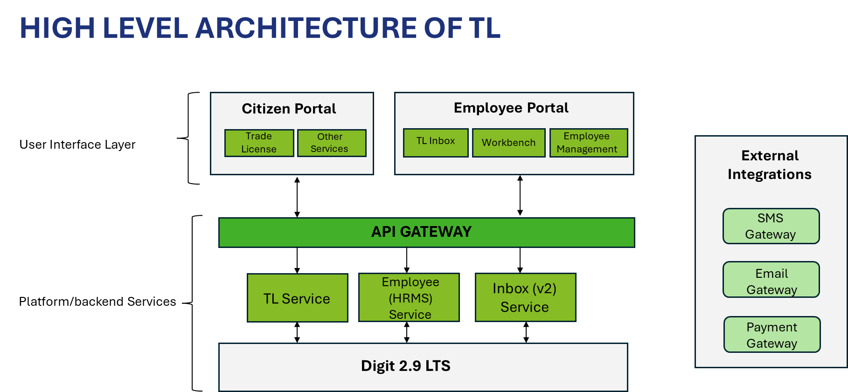
The diagram below provides a detailed view of the system components:
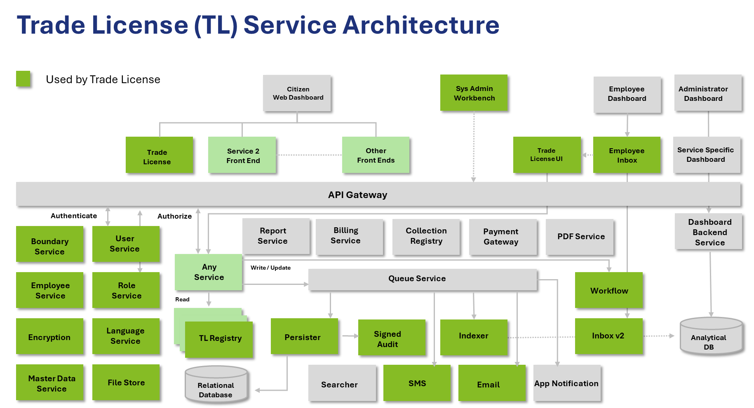

Solution Architecture
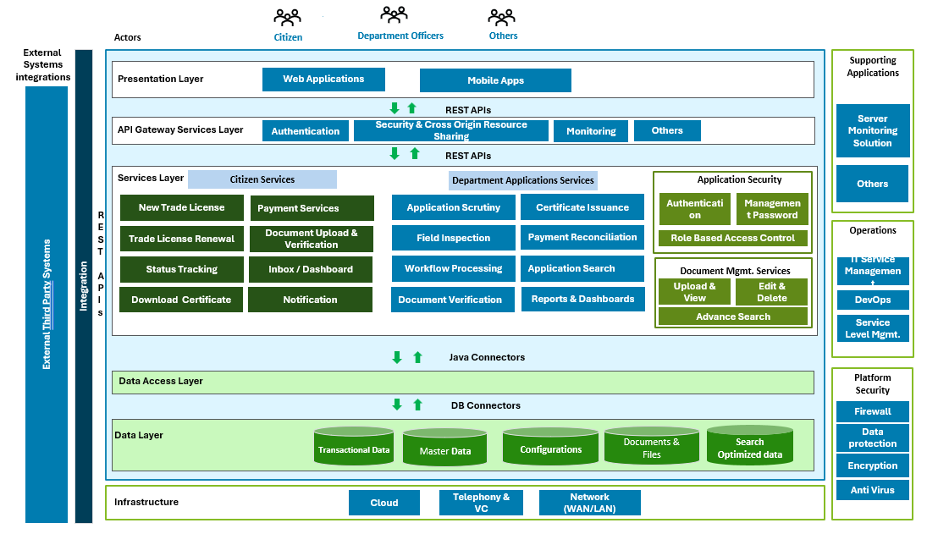

Workbench UI
The Workbench provides a UI to create, search, and edit master data for all services on the DIGIT platform. It functions with MDMS v2.

Employee Service & UI (HRMS)
This service is used to create, edit, search, and map employees to roles. Roles are defined as master data. The ULB user roles are assigned to employees through this service.

Inbox Service (v2)
The Trade License (TL) Issuance and Payment uses the Inbox Service to show employees the action items that need their attention. Inbox v2 uses ElasticSearch indexes, which are updated by the TL service. The query logic is configured and stored as master data.

Low Level Design (LLD)
Purpose: Detailed design to implement Trade License lifecycle — apply, pay, scrutiny, field verification, approve/reject, issue license, renew, revoke.
Scope: Citizen portal + employee portal + integrations with MDMS, Payment Gateway, Demand & Collection, Workflow, Filestore, User & Location services.
Assumptions: Uses DIGIT common services (IDGen, Filestore, Workflow v2, MDMS, User, Location, Notification, Demand & Collection). Tenant-aware multi-ULB.

TL Service Flow
Component | Description
tl-service (API) | Exposes REST endpoints for TL operations (create/search/update/license issuance/renewal).
tl-core (business logic) | Validation, fee calc orchestration (calls MDMS), demand generation, workflow triggers.
tl-worker / consumers | Async consumers for payment callbacks, demand updates, notifications, periodic SLA tasks.
filestore adapter | Upload/validate/store documents, return fileStoreId.
workflow integrator | Start/process workflow transitions via workflow service.
demand & collection integrator | Create demand, listen for payment receipts, and update application status.
notification publisher | Compose/send SMS/Email/in-app.

Primary Use Cases / Flows
- Apply for new trade license
- Upload supporting documents
- Fee assessment & demand generation
- Payment & receipt reconciliation
- Workflow-driven scrutiny (approve/reject/send-back)
- Field verification (optional)
- Certificate generation & registry update
- Renewal & cancellation

API Contracts (key endpoints)

Create Applications
POST /tl/v1/trade/_create
Request (essentials):
{
"RequestInfo": { /* user & auth */ },
"TradeLicense": {
"tenantId":"pb.amritsar",
"tradeLicenseDetail": {
"applicationType":"NEW",
"tradeUnits":[
{
"tradeType":"GROCERY",
"uom":"SFT",
"uomValue":200,
"ownershipCategory":"INDIVIDUAL",
"licenseCategory":"COMMERCIAL"
}
],
"applicant": {
"name":"Vikas",
"mobileNumber":"91xxxx",
"gender":"MALE",
"emailId":"a@b.com",
"permanentAddress": { "locality": "Ward-12", "city":"Amritsar" }
},
"address": { "doorNo":"12", "street":"MG Road", "locality":"Ward-12" },
"documents":[ { "fileStoreId":"fs-uuid", "documentType":"ID_PROOF" } ],
"channel":"MOBILE",
"businessPlace":"Shop"
}
}
}
Response: 201 with created tradeLicenseId, applicationNumber, initial status: INITIATED.

Update Application
POST /tl/v1/trade/_update
Used for send-back updates, attachments, and corrections.

Search Application
POST /tl/v1/trade/_search
Supports filters: tenantId, applicationNumber, status, licenseNumber, ownerId, date range, locality, tradeType, mobile.

Generate Demand for Application
POST /tl/v1/demand/_generate
Called internally by tl-core after fee calc.

Payment Callback
POST /tl/v1/payment/_callback
Receives PG response, updates demand/receipt, transitions workflow.

Approve/Reject/Forward (employee actions)
POST /tl/v1/workflow/_transition
Payload contains action, assignee, comments, businessId (applicationNumber).

Issue License
POST /tl/v1/trade/_issue
Generates license PDF, writes to trade_license registry, returns licenseNumber and fileStoreId.

Data Model (Tables, fields, indexes)

Core Tables (Postgres)
tl_trade_application
- id UUID PK
- tenantid VARCHAR
- applicationnumber VARCHAR UNIQUE
- status VARCHAR (INITIATED, PAYMENT_PENDING, IN_REVIEW, ASSIGNED, FIELD_VERIFICATION, APPROVED, REJECTED, LICENSE_ISSUED, CANCELLED)
- applicant_id UUID (FK to user/account or local store)
- applicant_name VARCHAR
- mobile_number VARCHAR
- email VARCHAR
- applicationtype VARCHAR (NEW/RENEWAL/AMENDMENT)
- businessplace VARCHAR
- address_id UUID FK
- createdby VARCHAR
- createdtime BIGINT
- lastmodifiedby VARCHAR
- lastmodifiedtime BIGINT
- sla_start_time BIGINT
- remarks TEXT
Indexes: (tenantid,status), (applicationnumber), (mobile_number), (createdtime desc)
tl_trade_unit — one or more trade units per application
- id UUID PK
- application_id UUID FK
- trade_type VARCHAR (MDMS code)
- uom VARCHAR
- uom_value NUMERIC
- license_category VARCHAR
- ownership_category VARCHAR
- proposed_from DATE
- proposed_to DATE
Indexes: (application_id)
tl_address
- id UUID PK
- door_no, building_name, street, locality, city, pincode, boundary_code
- lat DOUBLE, lng DOUBLE

tl_document
- id UUID PK
- application_id UUID FK
- file_store_id VARCHAR
- document_type VARCHAR
- uploaded_by VARCHAR
- uploaded_time BIGINT
tl_demand (local mapping to demand)

- id UUID PK
- application_id UUID FK
- demand_id VARCHAR (from Demand service)
- amount NUMERIC
- status VARCHAR (CREATED, PAID, PARTIAL, FAILED)
- receipt_id VARCHAR
- created_time BIGINT

tl_license_registry
- id UUID PK
- license_number VARCHAR UNIQUE
- application_id UUID FK
- license_file_store_id VARCHAR
- issue_date DATE
- expiry_date DATE
- status VARCHAR (ACTIVE, EXPIRED, REVOKED)
tl_workflow_action
- id UUID PK
- application_id UUID FK
- action VARCHAR
- from_state VARCHAR
- to_state VARCHAR
- assignee VARCHAR
- comments TEXT
- timestamp BIGINT

MDMS Reference Tables (cached)
- tl_trade_types (tradeTypeCode, description, defaultUOM)
- tl_fees (tradeType, uom, slabFrom, slabTo, ratePerUOM, effectiveFrom, taxableFlag)
Cache these in Redis with TTL; use to calculate fees.

Fee Calculation & Demand Generation
- Input: trade units (uom + value), trade type, tenantId, license duration
- Algorithm:
  - Fetch fee slabs for tradeType + tenantId from MDMS (fallback to state MDMS).
  - For each unit compute base = sum(rate * uomValue across applicable slabs).
  - Apply multipliers (late fee, rebate for short duration if any).
  - Compute taxes (GST/cess if applicable — use MDMS tax config).
  - Generate a single demand with line items per fee component via Demand & Collection service: POST /demand/_create.
- Edge cases: No MDMS entry → return error code TL_MDM_404.

Workflow Design
- States: INITIATED → PAYMENT_PENDING → IN_REVIEW → ASSIGNED → FIELD_VERIFICATION (optional) → APPROVED → LICENSE_ISSUED → CLOSED
- Actions: SUBMIT, PAY, FORWARD, ASSIGN, FIELD_VERIFY, APPROVE, REJECT, ISSUE_LICENSE, CANCEL
- Implement workflow with workflow service; each transition stored in tl_workflow_action.

Sequence Flows (high-level)

New Application -> Issue License
- Citizen POST /tl/_create → tl-service validates payload.
- tl-service stores application (tl_trade_application) with status INITIATED.
- tl-service calls fee calculator → creates demand (/demand/_create) and stores tl_demand.
- Application status → PAYMENT_PENDING. UI shows demand/redirect to PG.
- Citizen pays on PG → Payment gateway posts callback to /tl/payment/_callback.
- tl-service validates receipt with Demand service (/collection/search), marks tl_demand PAID and updates application status to IN_REVIEW.
- tl-service triggers workflow start (ACTION=SUBMIT).
- Employee accesses application → performs scrutiny, ASSIGN/RETURN/SEND_BACK. Actions recorded in tl_workflow_action.
- On APPROVE, tl-service calls license generation (PDF), writes tl_license_registry, status LICENSE_ISSUED, and generates notifications to citizens.

Integrations

- MDMS: trade types, fees, license duration, tax rules.
- Demand & Collection: demand creation, receipt validation. Use consumerCode = applicationNumber, businessService = TL.
- Payment Gateway: redirect + callbacks, map PG txn → receipt → update demand status.
- Workflow v2: start workflows, transitions.
- Filestore: document upload → returns fileStoreId.
- User Service: fetch employee/citizen details (UUID, roles).
- Location Service: validate boundary/locality.
- Notification Service: SMS/email templates.

UI/UX Details

- Citizen UI: multi-step wizard: Applicant → Trade details (repeatable units) → Address → Documents → Summary → Pay.
- Employee UI: Search, Filters (status, locality, tradeType, applicationNo), Review panel with documents, Assign/Forward buttons, Field Verification form (photo upload), Approve/Reject.
- Validation rules:
  - Mandatory: tenantId, tradeType, uomValue > 0, address.locality, applicant.mobileNumber
  - Documents: required per MDMS (e.g., ID_PROOF mandatory for new applications)

Security & RBAC

- Auth: JWT tokens via egov-user service.
- Tenant enforcement: every API must check tenantId.
- Role mapping: CITIZEN, EMPLOYEE_TL_REVIEWER, EMPLOYEE_TL_APPROVER, FIELD_INSPECTOR, ADMIN.
- Audit: capture audit_details on each DB row (createdby/createdtime/lastmodifiedby).
- Input sanitization: sanitize strings before DB insertion to prevent SQL/NoSQL injection.
- File checks: virus-scan (if available) + file-type & size validation before filestore upload.

Non-Functional Requirements & Perf

- Response times: create/search under 1s (search may be paginated).
- Concurrency: lock application record during employee update to avoid race conditions.
- Scaling: stateless microservice; scale pods based on CPU & request rate.
- Caching: MDMS & fee tables cached in Redis with TTL 5–15 minutes.
- DB: partitioning strategy by tenantId for high scale ULBs.
- Indexing: apply indexes on (tenantid, status), applicationnumber, createdtime, mobile_number.

Error Handling & Codes (examples)

- TL_400_INVALID_PAYLOAD — missing mandatory fields.
- TL_404_MDMS — fee config missing.
- TL_409_INVALID_WORKFLOW — invalid action for current state.
- TL_500_DEMAND_ERROR — Demand service failure.
- TL_502_PG_TIMEOUT — PG callback timeout.

Each API returns error object with code, message, and details.

Monitoring & Logging

- Structured logs (JSON) with requestId, userId, tenantId, applicationNumber.
- Metrics: application creations/sec, payments/sec, average fee calc time, workflow transitions/sec.
- Alerts: high failure rate in demand generation, PG callback failures, filestore errors.
- Tracing: distributed tracing with traceId.

Sample DB DDL (Postgres snippets)

CREATE TABLE tl_trade_application (
id uuid PRIMARY KEY,
tenantid varchar NOT NULL,
applicationnumber varchar UNIQUE NOT NULL,
status varchar NOT NULL,
applicant_id varchar,
applicant_name varchar,
mobile_number varchar,
email varchar,
applicationtype varchar,
businessplace varchar,
address_id uuid,
createdby varchar,
createdtime bigint,
lastmodifiedby varchar,
lastmodifiedtime bigint
);

CREATE INDEX idx_tl_tenant_status ON tl_trade_application (tenantid, status);
CREATE INDEX idx_tl_appnum ON tl_trade_application (applicationnumber);

Test Cases (high-level)

- Happy paths:
  - Create new application → demand created → pay → approve → license issued.
  - Renewal: existing license number used, fee calc with discount.
- Negative tests:
  - Create with invalid MDMS code → expect 400+TL_404_MDMS.
  - Payment callback with mismatched amount → reject and flag for manual reconcile.
  - Race: two employees try to approve simultaneously → second attempt should get 409.
- Integration tests:
  - Demand creation + receipt verification with stub Demand service.
  - Filestore upload & retrieval.
  - Workflow transitions (start, assign, approve).
- Security tests:
  - Unauthorized user attempts approve — expect 403.
  - Tenant breach attempt (cross-tenant access) — expect 403.

Sample JSONs

Fee Calc Request
{
"tenantId":"pb.amritsar",
"tradeUnits":[
{ "tradeType":"GROCERY", "uom":"SFT", "uomValue":200 }
],
"durationMonths":12
}

Demand creates payload (to demand service)
{
"RequestInfo": { },
"Demands":[
{
"tenantId":"pb.amritsar",
"consumerCode":"TL_APP_2025_0001",
"businessService":"TL",
"demandDetails":[
{ "taxHeadMasterCode":"TL_FEE_BASE", "taxAmount":1200 },
{ "taxHeadMasterCode":"TL_GST", "taxAmount":216 }
]
}
]
}

Data Flow Diagram (DFD) Level 0 – Context Diagram (DIGIT Trade License Module)

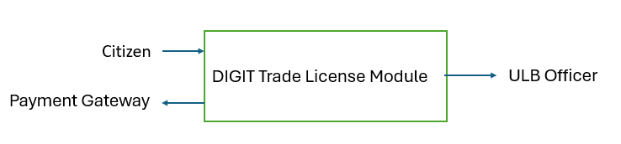
Data flows:
- Citizen submits application
- Module interacts with workflow, payment, MDMS, and ULB officers
- Officer reviews/approves/rejects
- Citizen receives certificate/status

DFD Level 1 – Major Functional Breakdown

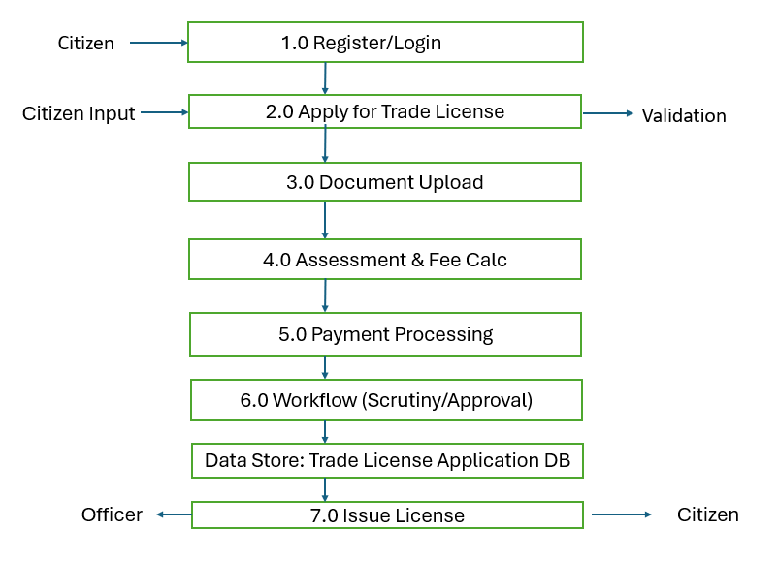

DFD Level 2 – Detailed Breakdown of Key Modules

Level 2 for 2.0 Apply for Trade License
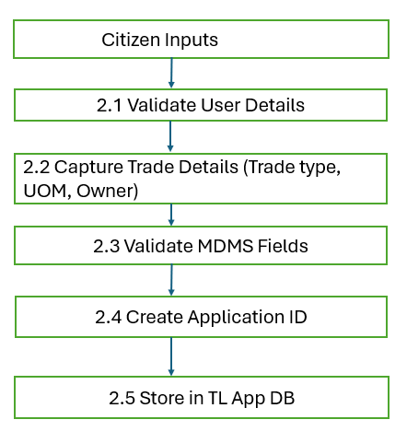

Level 2 for 3.0 Document Upload

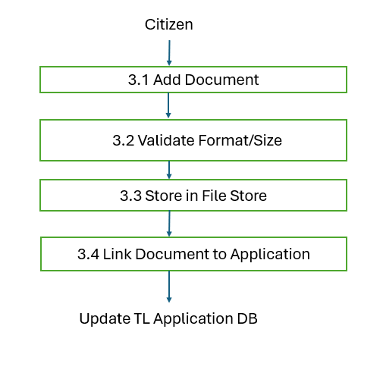

Level 2 for 4.0 Assessment & Fee Calculation

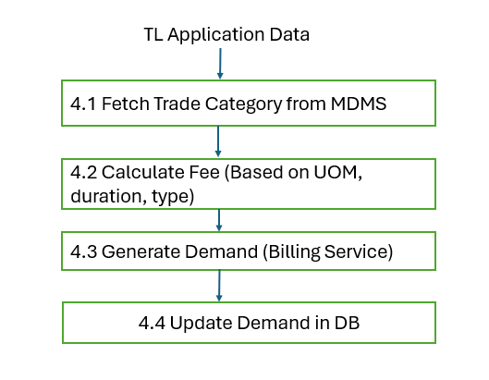

Level 2 for 5.0 Payment Processing

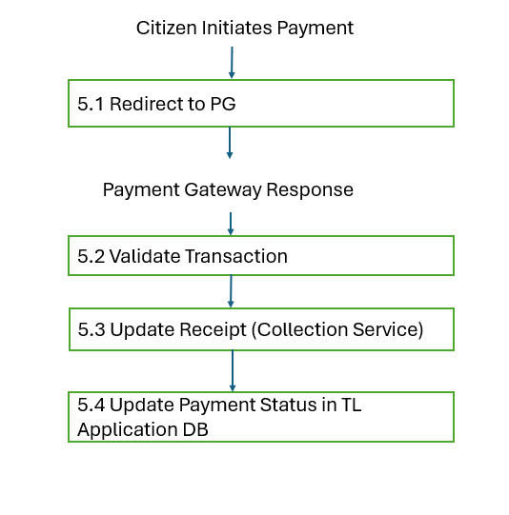

Level 2 for 6.0 Workflow (Scrutiny/Approval)

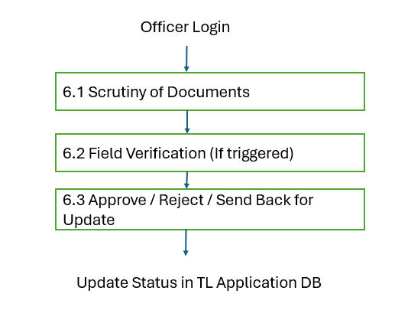

Level 2 for 7.0 Issue License

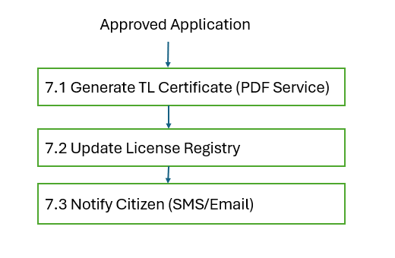

API specification for Trade License

info:
title: Trade License Service API
version: 1.0.0
servers:
- url: https://{host}
variables:
host:
default: api.digit.org
paths:
/tl-services/v1/_create:
post:
summary: Create a Trade License Application
tags:
- Trade License
requestBody:
required: true
content:
application/json:
schema:
$ref: '#/components/schemas/TradeLicenseRequest'
responses:
'201':
description: Created
content:
application/json:
schema:
$ref: '#/components/schemas/TradeLicenseResponse'
/tl-services/v1/_update:
post:
summary: Update a Trade Trade License Application
tags:
- Trade License
requestBody:
required: true
content:
application/json:
schema:
$ref: '#/components/schemas/TradeLicenseRequest'
responses:
'200':
description: Updated
/tl-services/v1/_search:
post:
summary: Search Trade License Applications
tags:
- Trade License
requestBody:
required: false
content:
application/json:
schema:
$ref: '#/components/schemas/TradeLicenseSearchRequest'
responses:
'200':
description: Success
content:
application/json:
schema:
$ref: '#/components/schemas/TradeLicenseResponse'
/tl-services/v1/_license:
post:
summary: Issue a Trade License Certificate
tags:
- Trade License
responses:
'200':
description: License Issued
components:
schemas:
RequestInfo:
type: object
properties:
apiId: { type: string }
ver: { type: string }
ts: { type: number }
action: { type: string }
key: { type: string }
msgId: { type: string }
authToken: { type: string }
TradeUnit:
type: object
properties:
tradeType: { type: string }
uom: { type: string }
uomValue: { type: number }
TradeLicenseDetail:
type: object
properties:
applicationType: { type: string }
channel: { type: string }
tradeUnits:
type: array
items:
$ref: '#/components/schemas/TradeUnit'
address:
type: object
owner:
type: object
documents:
type: array
items:
type: object
TradeLicense:
type: object
properties:
tenantId: { type: string }
applicationNumber: { type: string }
licenseNumber: { type: string }
status: { type: string }
tradeLicenseDetail:
$ref: '#/components/schemas/TradeLicenseDetail'
TradeLicenseRequest:
type: object
properties:
RequestInfo:
$ref: '#/components/schemas/RequestInfo'
TradeLicense:
$ref: '#/components/schemas/TradeLicense'
TradeLicenseResponse:
type: object
properties:
ResponseInfo:
type: object
TradeLicense:
type: array
items:
$ref: '#/components/schemas/TradeLicense'
TradeLicenseSearchRequest:
type: object
properties:
RequestInfo:
$ref: '#/components/schemas/RequestInfo'
searchCriteria:
type: object
properties:
applicationNumber: { type: string }
licenseNumber: { type: string }
mobileNumber: { type: string }
status: { type: string }
tenantId: { type: string }

Trade License – ER Diagram (Textual Representation)

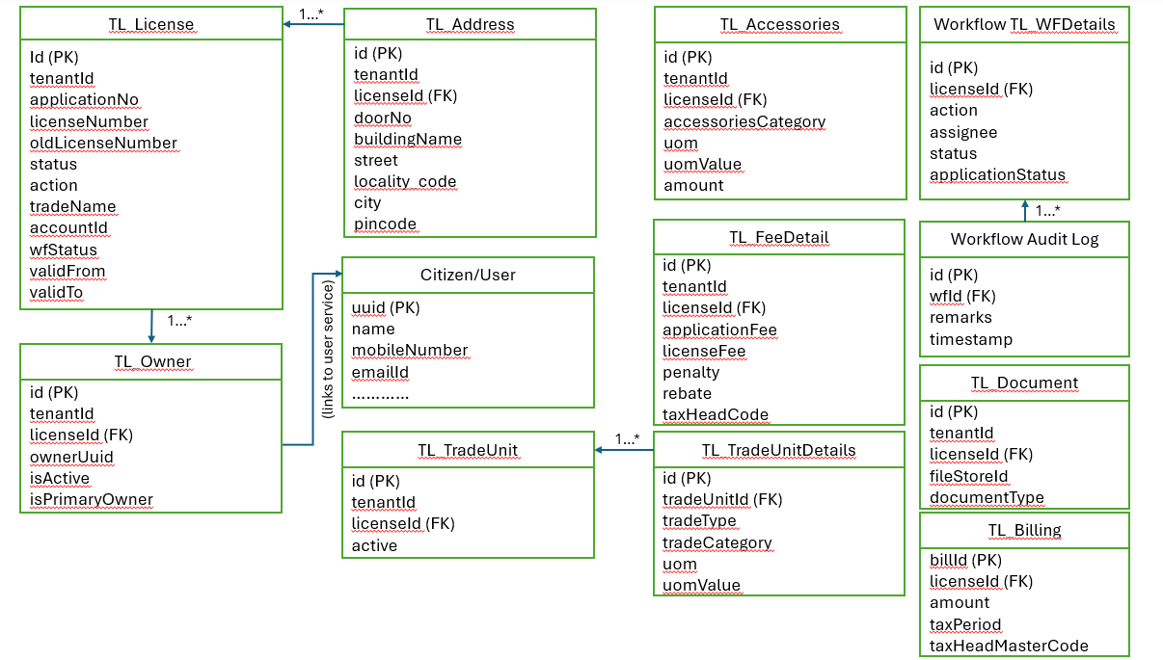

Explanation of DIGIT TL Core Entities

TL_License
Main record containing:
- license number
- status & workflow state
- validity
- tenant (ULB)
Primary entity for the module.

TL_Address
Stores trade location:
- door number
- locality
- pincode
- building details
Each license can have one primary address.

TL_Owner
Links each license to:
- citizen
- multiple owners
- primary owner flag
Uses ownerUuid to connect with DIGIT User Service.

TL_TradeUnit
Represents the line of business:
- trade category
- trade type
- UOM info
A license can have multiple trade units.

TL_Accessories
Trade accessories:
- generators
- refrigerators
- other equipment used for fee calculation.

TL_FeeDetail
Contains:
- Base license fee
- Penalty
- Rebate
- Tax head linkage
Used by Billing & Collection.

TL_Document
Uploaded applicant documents:
- ID proof
- Trade proof
- Others

TL_WFDetails
Workflow integration:
- APPROVE
- FORWARD
- REJECT
- SEND BACK
Tracks status transitions.

TL_Billing
For integration with:
- Billing Service
- Collection Service
Stores tax and fee data.
- CI/CD Lifecycle for PGR and TL
  - Overview
This diagram explains, in a single picture, how code ravels from a developer’s workstation to production in a continuous way
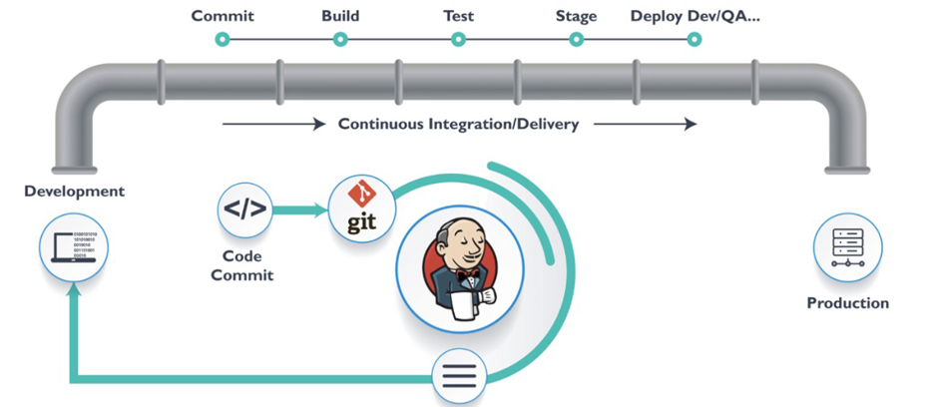
Description:
On the left we have Development, representing developers working microservices. When they are ready, they perform a Code Commit to Git (GitHub).
The top “pipe” shows the end-to-end lifecycle of that change:
- Commit – code is pushed to the central repo.
- Build – the application is compiled/packaged.
- Test – automated tests are executed.
- Stage – the change is deployed into a staging/UAT environment.
- Deploy Dev/QA/Prod – the same CI/CD mechanism promotes the change all the way to production.
Jenkins is shown in the centre because it orchestrates this entire flow:
- It is triggered when commits happen,
- It runs the build and tests, and it initiates deployments into the different environments.

  - CI vs CD Pipeline Breakdown
This diagram explains the separation of responsibilities between the CI pipeline and the CD pipeline. This is important for governance and for explaining what quality gates exist before anything reaches production.
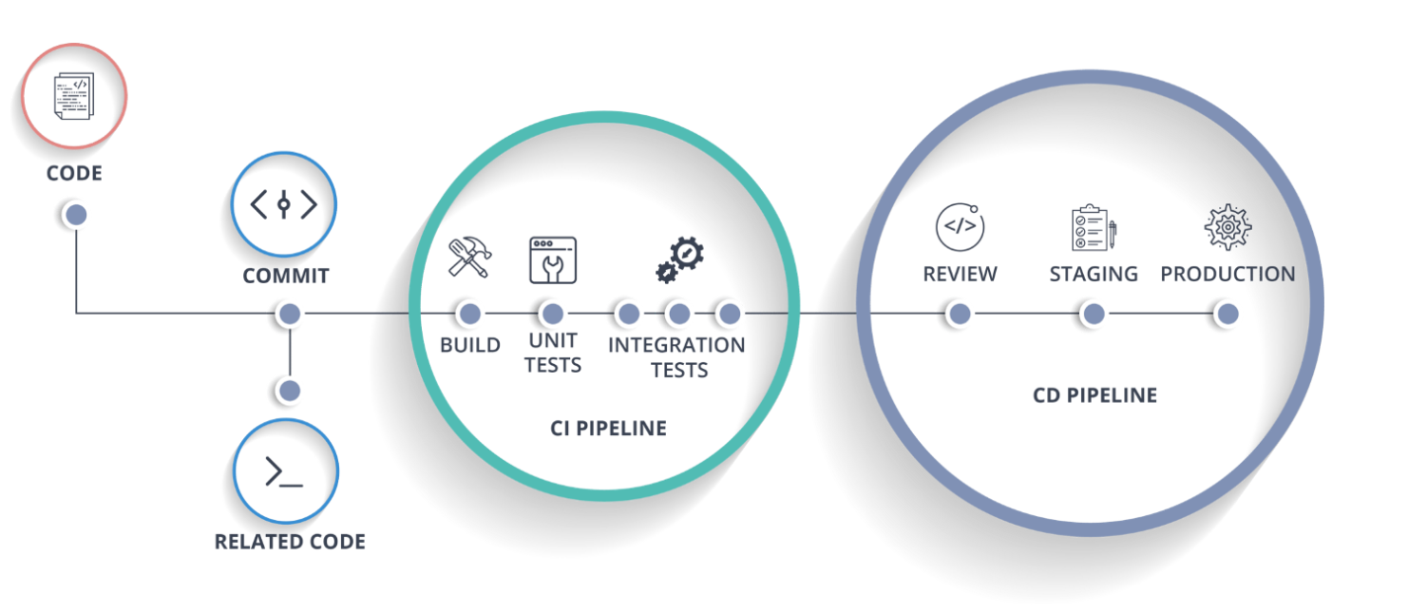
Description:
CI Pipeline:
- Build – compile/package the TL/PGR service, resolve dependencies.
- Unit Tests – fast tests that validate individual methods/classes.
- Integration Tests – broader tests that validate interaction with DB, other DIGIT services, etc.
We can say that CI must always complete successfully before anything is eligible for deployment.
CD Pipeline:
Inside the blue circle:
- Review – code review / merge approval.
- Staging – deployment into a staging/UAT environment where integrated TL/PGR flows are tested end-to-end.
- Production – deployment into the live environment.
- Promotion from CI → CD is usually driven by Jenkins using manual or automated approvals.
- The same build artifact (Docker image) is promoted across environments to maintain integrity.

Environment Deployment Architecture
This is the implementation diagram: it shows how the logical CI/CD concepts from Diagrams 1 and 2 are realized with actual tools (GitHub, Jenkins, Docker registry, Kubernetes) and how they target the different Kubernetes clusters (Dev, UAT, Prod on EKS).
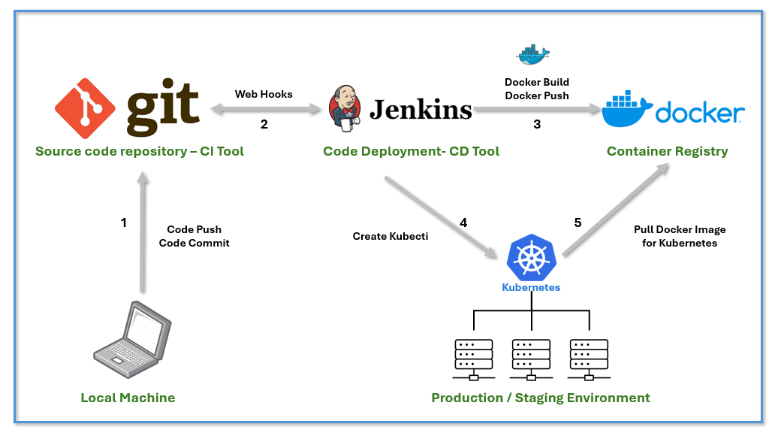
Description:
- Code Push / Code Commit (from Local Machine to GitHub):
  - Developers push service code from their local machine to the central Git repository.
- Webhook from GitHub to Jenkins
  - GitHub sends a webhook notification to Jenkins when new commits are pushed or PRs are merged.
  - This automatically triggers the CI pipeline (build + tests).
- Docker Build & Docker Push to Container Registry
  - Jenkins uses Shell/Bash/Groovy scripts to:
    - Build a Docker image for the service,
    - Tag it appropriately (e.g., version, commit SHA), and
    - Push it to a container registry – ECR (primary),registry/DockerHub as alternatives.
- Helm Deploy from Jenkins to Kubernetes
  - Once the image is in the registry and CI checks have passed, Jenkins executes Helm charts to deploy or upgrade the service on Kubernetes.
  - Helm values control which environment (Dev, UAT, Prod) is targeted and what configuration (DB URLs, Kafka endpoints, DIGIT config) is used.
- Kubernetes Docker Image Pull
  - The Amazon EKS pull the required image from the registry and start the pods.
  - The dashed arrow shows that runtime clusters depend on the registry for images built in step 3.
At the bottom, the box labelled “Dev, UAT and PROD Kubernetes Clusters” indicates that:
- The same DevOps pipeline pattern is used for all environments.
- Only the target cluster and Helm values change (e.g., Dev EKS vs Prod EKS )

Infrastructure Architecture for DIGIT TL & PGR on AWS EKS
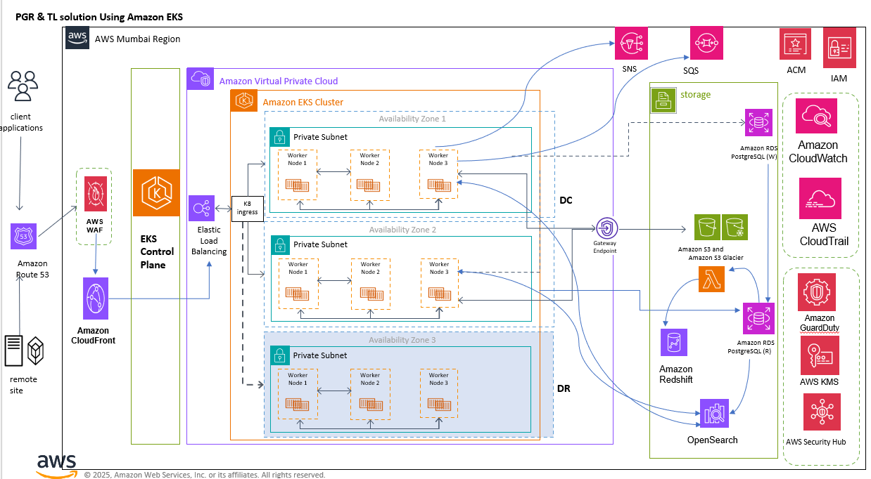
This diagram shows the end-to-end AWS infrastructure used to run the DIGIT-based PGR and TL solution in the AWS Mumbai region. It covers client access, networking, multi-AZ EKS cluster, data services, analytics, and security/observability.
1. Client access and edge services
- Client applications / remote sites
  - Citizens, employees and external systems connect over the internet or via remote networks.
- Amazon Route 53
  - Public DNS service hosting the TL & PGR domain records
  - Routes user requests to Amazon CloudFront.
- Amazon CloudFront
  - Global CDN in front of the application.
  - Caches static assets (frontend bundles, images, PDFs) close to users, improving performance and reducing load on origin.
  - Acts as the primary public entry point for all citizen and employee portals.
- AWS WAF
  - Web Application Firewall attached to CloudFront.
  - Protects the application from common web attacks (SQL injection, XSS, bots, abnormal traffic patterns).
  - Rules can be customised for government-specific security policies.
- 2. Kubernetes control plane and VPC
- EKS Control Plane
  - Fully managed Kubernetes control plane (masters) provided by AWS.
  - Placed in a separate control-plane VPC managed by AWS; accessed securely from the customer VPC.
- Amazon Virtual Private Cloud (VPC)
  - Dedicated VPC for the PGR & TL solution in AWS Mumbai region.
  - Contains all worker nodes, application pods and data services in private subnets spread across multiple Availability Zones for high availability.
- Elastic Load Balancing (K8s Ingress)
  - CloudFront → WAF → Application Load Balancer (ALB) in the VPC.
  - ALB passes traffic to the Kubernetes ingress controller (K8 ingress) which performs host/path-based routing to individual DIGIT, TL and PGR services.
- 3. Highly available EKS cluster (multi-AZ + DR)
- Amazon EKS Cluster
  - Deployed across three Availability Zones:
    - Availability Zone 1 & 2 – DC (Primary data centre)
      - Each AZ hosts a private subnet with multiple worker nodes (Node 1, Node 2, Node 3).
      - Application pods are spread across nodes and AZs using Kubernetes scheduling for resilience.
    - Availability Zone 3 – DR (Disaster Recovery)
      - Additional private subnet and worker nodes reserved for DR and fail-over capacity.
  - All worker nodes are private (no public IPs). Outbound internet access, if required, is through NAT/Gateway endpoints.
- Workload placement
  - DIGIT core services, TL microservices and PGR microservices run as containers across these worker nodes.
  - System components such as ingress controller, metrics/logging agents and sidecars also run in the same cluster.
- 4. Storage, databases and analytics
This section on the right of the diagram represents the data and analytics layer.
- Gateway Endpoint
  - VPC gateway endpoint (for example, to S3) allows private connectivity between the VPC and storage services without traversing the internet.
- Storage block
  - Amazon RDS PostgreSQL (W) – primary write database for DIGIT, TL and PGR modules.
    - Deployed in multi-AZ mode for durability.
  - Amazon RDS PostgreSQL (R) – read replica used for reporting and heavy read workloads, offloading the primary.
  - Amazon S3 / Amazon S3 Glacier – object storage:
    - Citizen documents, attachments, PDF outputs.
    - Long-term archival to Glacier for compliance.
  - AWS Lambda – serverless compute for data processing, ETL and archiving tasks between OLTP database, S3 and analytics systems.
- Analytics and search
  - Amazon Redshift
    - Data warehouse for analytical workloads, dashboards and MIS reporting on TL & PGR data.
    - Periodically populated from RDS and/or S3 via Lambda jobs.
  - OpenSearch
    - Used for full-text search and log/metric indexing (application logs, audit trails, etc.).
    - Allows fast search on grievances, trade licences, and system logs.
- Messaging and integration
  - Amazon SNS
    - Pub/Sub notifications (e.g. SMS/email events, async notifications to external systems).
  - Amazon SQS
    - Durable queues for asynchronous processing (background jobs, retries, integration with external government systems).
- 5. Security, identity and observability
The right-most vertical column groups the security, identity and monitoring services that support the platform.
- AWS Certificate Manager (ACM)
  - Manages TLS certificates for domains used by TL/PGR applications.
  - Certificates are attached to CloudFront and ALB.
- AWS IAM
  - Central identity and access management.
  - Defines IAM roles for:
    - EKS worker nodes & service accounts (IRSA),
    - Jenkins/App Runner/other CI components,
    - Lambda functions and analytics jobs.
- Amazon CloudWatch
  - Metrics, logs and alarms for all AWS and application components (EKS nodes, pods, RDS, Lambda, Redshift, etc.).
- AWS CloudTrail
  - Records all API calls and console actions, providing full audit trail for compliance and security investigations.
- Amazon GuardDuty
  - Continuous threat detection service.
  - Monitors VPC flow logs, DNS logs and CloudTrail events to detect suspicious activity.
- AWS KMS
  - Key Management Service used to encrypt:
    - RDS databases,
    - S3 buckets,
    - EBS volumes and application secrets.
- AWS Security Hub
  - Centralises security findings from GuardDuty, Inspector, Config, etc.
  - Provides a single pane for security posture of the PGR & TL environment.

